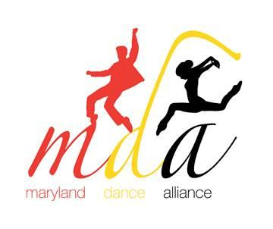
8th Annual Maryland Dance Alliance
Intent Form
EVENT DATE: Friday, February 28, 2020 @ The Gordon Center for Performing Arts
SNOW DATE: Monday, March 3, 2020
INTENT DUE: OCTOBER 1, 2019 to mddancealliance@gmail.com

Dance Instructor's Information

Name:

Position:

School/Studio/Program Name:

School/Studio/Program Address:

City:

School Phone :

Home Phone:

Email Address (school or studio):

Other Information

NHSDA Chapter #:

County or School District:

Private School _____ Public School ______ Private Studio _____ Community/Other _____

Number of dancers performing (minimum 5, maximum 20):

Will you require a parking space for bus service? Yes ___No___

Dance Instructor's Signature: Principal/Director’s Signature

___________________________________ ________________________________________
(Required Signature) (Required Signature)

