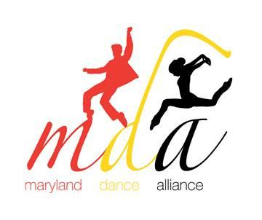
School Information Form
Due: November 21, 2019

This form is for schools that will be attending the Maryland Dance Alliance but not submitting a work for the adjudication/evening performance.

NDEO Institutional Member #:  (Required) |  | NHSDA Chapter #:  (Required)

School/Studio Name: __________________________________________________________
Dance Instructor’s Name: ______________________________________________________
School Phone: _________________________________________________________________
Email Address (school): _________________________________________________________
Number of dancers: ________ (minimum 5/maximum 20)
Dancer’s Names:
**Please place in alphabetical order. For example: John Doe (First Name Last Name)**

1. | 11.
2. | 12.
3. | 13.
4. | 14.
5. | 15.
6. | 16.
7. | 17.
8. | 18.
9. | 19.
10. | 20.

Once this form is received, you will get a confirmation email.

Please send form by November 21st to mddancealliance@gmail.com.

