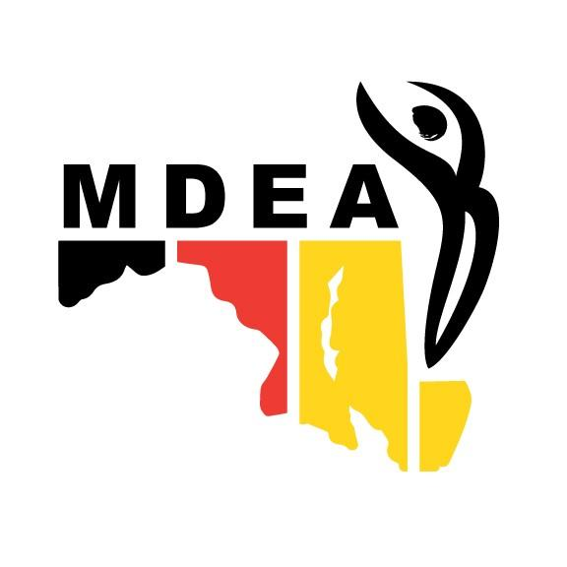
MARYLAND DANCE EDUCATION ASSOCIATION
NDEO National Conference Scholarship
for MDEA Members

In keeping with the mission to support further study and professional growth in dance and dance education, MDEA is offering a scholarship to MDEA members to cover the conference registration fee for an upcoming NDEO Conference.
Scholarships will be funded in the amount of the conference registration fee up to $400.

SCHOLARSHIP CRITERIA:
Scholarship applications are to provide MDEA members with the opportunity for increased and broadened professional learning in the field of dance.
The intended experience should:
- recognize and promote scholarly interest,
- increase and promote new connections in the field,
- broaden knowledge,
- cultivate leadership in the field, and
- provide an experience which would lead to the recipient presenting at a future MDEA event.

ELIGIBILITY: Must be an active member of NDEO/MDEA throughout the period of the awarded experience.

- Undergraduate and graduate MDEA member studying dance education
- Current K-12 or college/university dance teacher
- Current teaching artist
- Administrator of Fine Arts Dance program

APPLICATION GUIDELINES:
The following application must be completed, addressing all items and criteria listed.

Scholarships will be awarded based on the merit of the application and will be selected in accordance with award criteria. Incomplete or late applications will not be considered for this scholarship.

All applications must be electronically submitted by the April 1, 2020 deadline to MDEA: info@mddanceed.org.

Completed applications will be reviewed by the MDEA Grants and Scholarships Committee. Award recipients will be notified and announced within 4 weeks after the application deadline.

Announcement of the scholarship will be shared in a spring MDEA e-newsletter. The awardee must attend an NDEO National Conference or a Special Topics Conference within a year of receiving the scholarship.

Questions about this application form should be sent to
info@mddanceed.org

MDEA SCHOLARSHIP APPLICATION

- Application and adjunct materials are due April 1 (electronic submission only)
- Submit completed application and adjunct materials to MDEA -- info@mddanceed.org
- The following are the maximum page guidelines (exceeding these guidelines will result in points deduction during evaluation and/or automatic rejection of project):
  - Two letters of recommendation:
    - One from an immediate supervisor, mentor, or counselor
    - One from someone who can speak to your work ethic (May or may not be dance related)
  - One-page resume
  - Save and submit all documents with the following titles: Last name, letter of rec #1 or letter of rec #2, or resume or transcript, MDEA Dance Scholarship. E.g. Smith_Resume_MDEADanceScholarship

GENERAL INFORMATION:

Name:
Email Address:
School/Institution: | Phone:
 | County:
Home Address (Including Zip Code):

Applicant’s Signature: | Date:

Have you ever applied for a MDEA Scholarship? | ☐Yes | ☐No
If YES:
Year LAST applied: | ☐ LAST Scholarship/Awarded | ☐ LAST Scholarship NOT Awarded

Have you ever attended an NDEO national or special topics conference? | ☐Yes | ☐No
If Yes:
Year(s) of attendance?

Description of Program of Study:
1. Explain the nature of your intended scholarship experience. Include a list of years that you have attended a national conference and whether you have presented at a National Conference - if applicable. (ex. National Conference, Special Topics Conference)
2. Purpose of conference attendance (clearly define your goal(s) as a dancer/dance educator, and how you think this experience will help you reach them)
250 words max
3. Follow-up commitment: Attendance at the Annual MDEA Conference and submitting a proposal to share what you have learned is required. Please check to acknowledge the commitment.
☐ Yes, I will attend the MDEA Conference Awards and Recognition Session – spring 2021 date TBD.
☐ Yes, I will present at a session at a future MDEA Conference.

