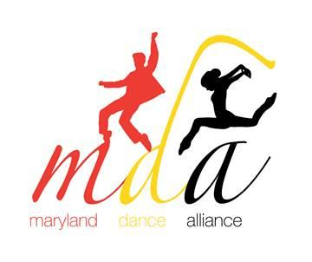

Program Information Form
Due: November 21, 2019
Please submit this form with your video/music submission.
Please submit lyrics and costume picture with this form. Each school may submit two (2) 4-minute (maximum length) pieces for adjudication with maximum of 20 dancers.
Use a separate form for each piece submitted.

NDEO Institutional Member #:  (Required) |  | NHSDA Chapter #:  (Required)
School/Studio Name: __________________________________________________________
Dance Instructor’s Name: ______________________________________________________
School Phone: _________________________________________________________________
Email Address (school): _________________________________________________________
Title of Piece: _________________________________________________________________
Style of Piece: ________________________________________________________________
Title of Music: _________________________________________________________________
Composer: ______________________________________ Lyrics: _____ Yes _____ No
Length of piece: _____ minutes _____ seconds
Number of dancers: ________ (minimum 5/ maximum 20) *Special permission is required for a program's class size larger than 20.
Title of Choreographer: _________________________________________________________
Dancer’s Names:
**Please place in alphabetical order by last name.**
1. | 11.
2. | 12.
3. | 13.
4. | 14.
5. | 15.
6. | 16.
7. | 17.
8. | 18.
9. | 19.
10. | 20.
OInce videos and music are received, you will get a confirmation email.

Please send video/form/music by November 21st to mddancealliance@gmail.com.

